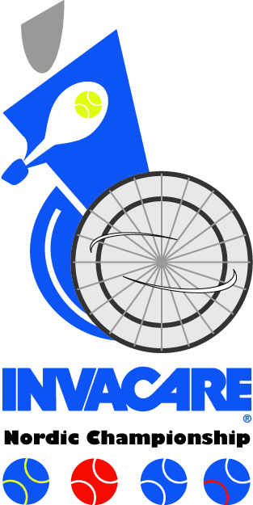
INVACARE NORDIC CHAMPIONSHIP WHEELCHAIR TENNIS, STOCKHOLM, OCTOBER 31- NOVEMBER 2, 2014
The Swedish Tennis Association and SALK would like to invite you to Invacare Nordic Championship to be held at SEB Salkhallen.
Venue: SEB Salkhallen (14 plexipave courts indoors), Gustavslundsvägen 159, 167 51 Bromma
Phone: +46 8 564 356 00
Contact person: Niclas Rodhborn, email: niclas.rodhborn@gmail.com
Tournament Director and referee: Johan Porsborn, email: johan.porsborn@salk.se
Events: Singles and Doubles for MEN, WOMEN, QUADS and JUNIORS.
Hotel: Scandic Hotel Alvik (just beside SEB Salkhallen), Gustavslundsvägen 153, 167 51 Bromma
Phone: + 46 8 517 661 00 Email: alvik@scandichotels.com. Please make room reservation to Johan Porsborn. Full accommodation, prize 180 euro, includes to share a double room for two nights, lunch and dinner on Friday, breakfast, lunch and official dinner on Saturday, breakfast and lunch on Sunday. Advance payment, no later than at Entry deadline, see below.
Program: Friday, October 31: Registration from 10:00 in SEB Salkhallen. Practice at 10:00-11:00. Lunch at 11:00-12:30. Captains meeting at 12:30. Opening ceremony at 13:00. Matches start at 13:30.
Saturday, November 1: Matches start at 10:00. Lunch at 12:00-14:00. Official dinner at 19:30.
Sunday, November 2: Matches start at 09:00. Lunch at 12:00-14:00. Prize ceremony at 13:00.
Transportation: Will be provided from and to Stockholm Arlanda or Bromma airport and ferry terminal.
Entry deadline: Please mail entries at the latest on October 6 to Johan Porsborn. Draw will be made and published at www.salk.se on Thursday evening, October 30.
Accommodation fee: 180 euro per player, which includes both singles and doubles and full hospitality. For players not wishing to stay at the official hotel the entry fee is 100 euro, which includes both singles and doubles and all meals except breakfasts. The non-refundable entry fee must be paid to SALK on October 6 at the latest. IBAN: SE4395000099603400576447 BIC: NDEASESS
Swedish players can pay to PlusGiro: 57644-7
Matches: Best of three tiebreak sets in singles. In doubles and singles consolation the third set will be played as a Match tiebreak. In the doubles matches no ad scoring will be used.
Main sponsor: Invacare
Co sponsors: Promobilia. Balls: Tretorn Serie +
MOST WELCOME TO STOCKHOLM!
