INVACARE Nordic Championship, October 31- November 2, 2014

Dear friends,
most welcome to Stockholm and Invacare Nordic Championship. We hope you will enjoy your stay with us!
Venue
SEB Salkhallen (14 plexipave courts indoors)
Contact: Niclas Rodhborn, email: niclas.rodhborn@gmail.com
mobile (in case of urgent matters): + 46 70 55 29 071
Tournament director and referee: Johan Porsborn, mobile: +46 70 19 19 520
Friday, October 31
10:00-12:30 Registration in SEB Salkhallen
10:00-11:00 Practice
11:00- 12:30 Lunch, club room
12:30 Captains meeting, club room
13:00 Opening ceremony, court 3
13:30 Matches start
18:00-21:00 Dinner at Scandic Hotel
Saturday, November 1
10:00 Matches start
12:00-14:00 Lunch, club room
19:30 Official dinner in SEB Salkhallen (the restaurant)
Sunday, November 2
10:00 Finals
12:00-14:00 Lunch, club room
13:00 Prize ceremony
Matches Best of three tiebreak sets in singles. In doubles and singles consolation the third set will be played as a Match tiebreak. In the doubles matches no ad scoring will be used.
Balls Tretorn Serie +

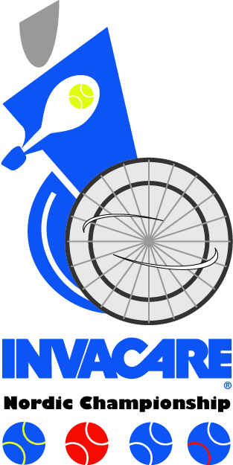
We wish all players in Invacare Nordic Championship the best of luck!
